Test Case: tc002_SPX_Dev5_Crear_Requisicion_Spot_Tipo_Cobro_Project
Step 1 - Enter username and password and click to button Enter: Credentials Entered
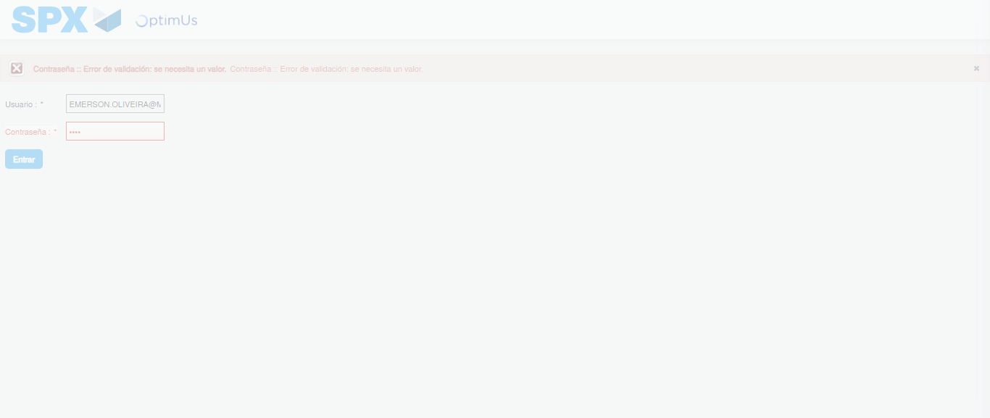Image file-name: QC_Testing-tc002_SPX_Dev5_Crear_Requisicion_Spot_Tipo_Cobro_Project-1784657992088

Step 2 - Select to UEN and Access to Spot Buy Requisitions : UEN Correctly selected and Correct access
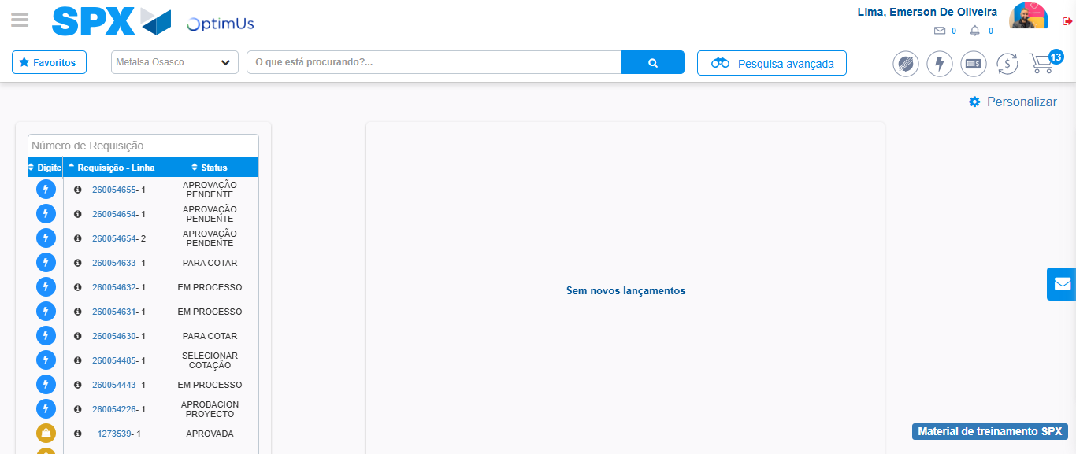Image file-name: QC_Testing-tc002_SPX_Dev5_Crear_Requisicion_Spot_Tipo_Cobro_Project-1784658017650

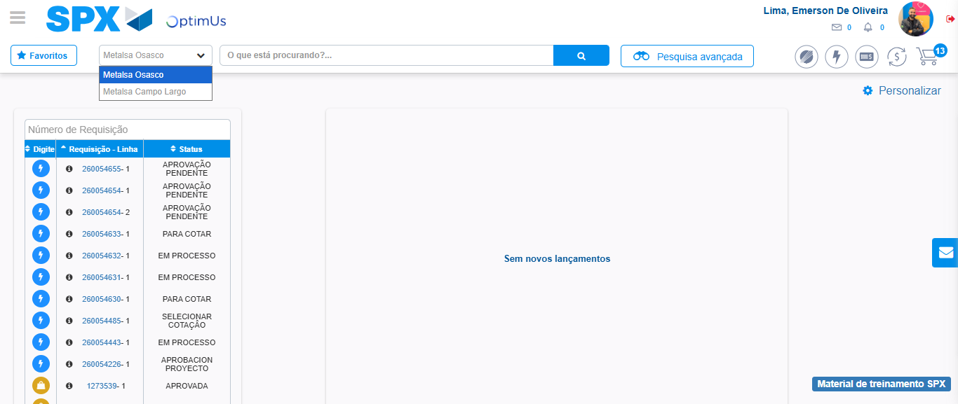Image file-name: QC_Testing-tc002_SPX_Dev5_Crear_Requisicion_Spot_Tipo_Cobro_Project-1784658020208

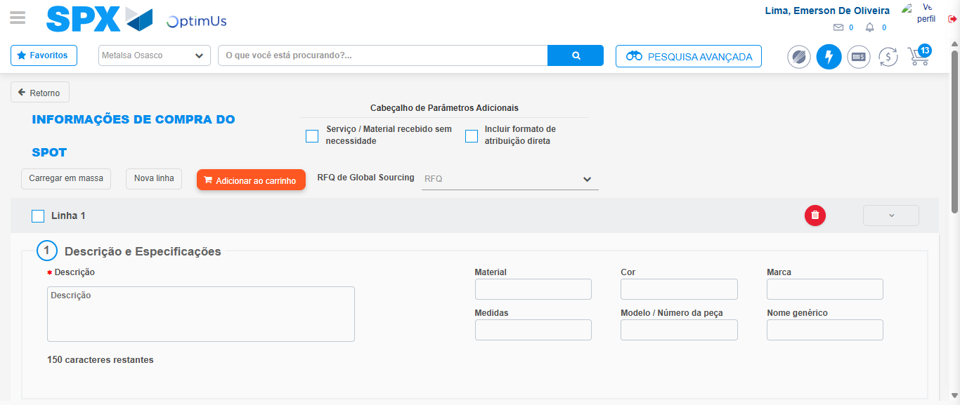Image file-name: QC_Testing-tc002_SPX_Dev5_Crear_Requisicion_Spot_Tipo_Cobro_Project-1784658038524

Step 3 - Data Capture Spot Buy Requisition: Data captured correctly
Image file-name: QC_Testing-tc002_SPX_Dev5_Crear_Requisicion_Spot_Tipo_Cobro_Project-1784658038761

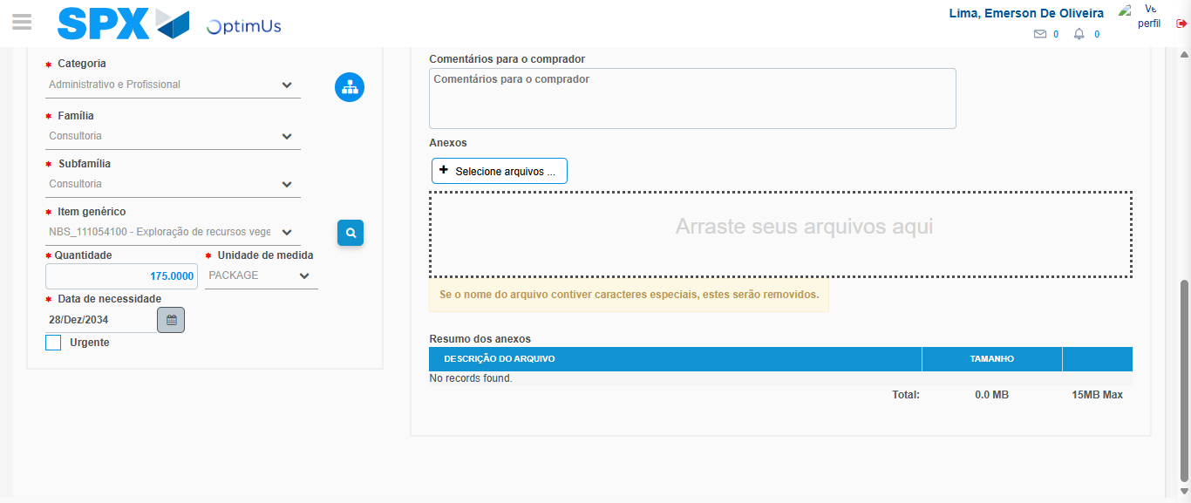Image file-name: QC_Testing-tc002_SPX_Dev5_Crear_Requisicion_Spot_Tipo_Cobro_Project-1784658051228

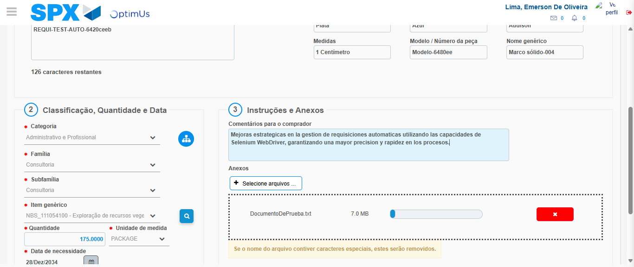Image file-name: QC_Testing-tc002_SPX_Dev5_Crear_Requisicion_Spot_Tipo_Cobro_Project-1784658051990

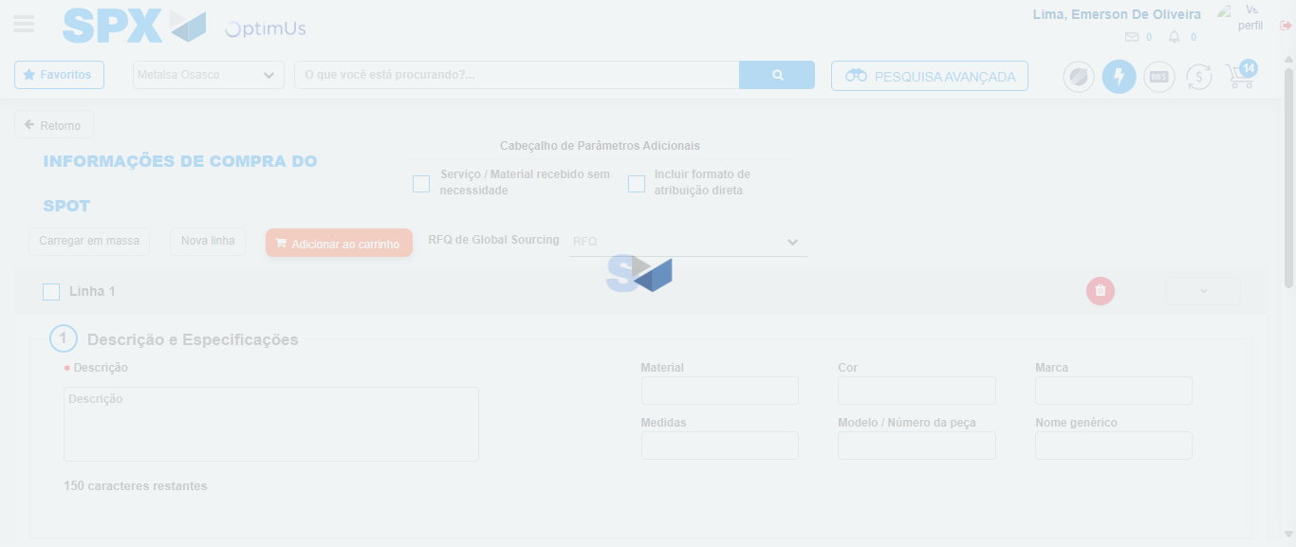Image file-name: QC_Testing-tc002_SPX_Dev5_Crear_Requisicion_Spot_Tipo_Cobro_Project-1784658053945

Step 7 - Return to Main Page SPX : Return to Main Page SPX
Image file-name: QC_Testing-tc002_SPX_Dev5_Crear_Requisicion_Spot_Tipo_Cobro_Project-1784658017650

Image file-name: QC_Testing-tc002_SPX_Dev5_Crear_Requisicion_Spot_Tipo_Cobro_Project-1784658020208

Image file-name: QC_Testing-tc002_SPX_Dev5_Crear_Requisicion_Spot_Tipo_Cobro_Project-1784658038524

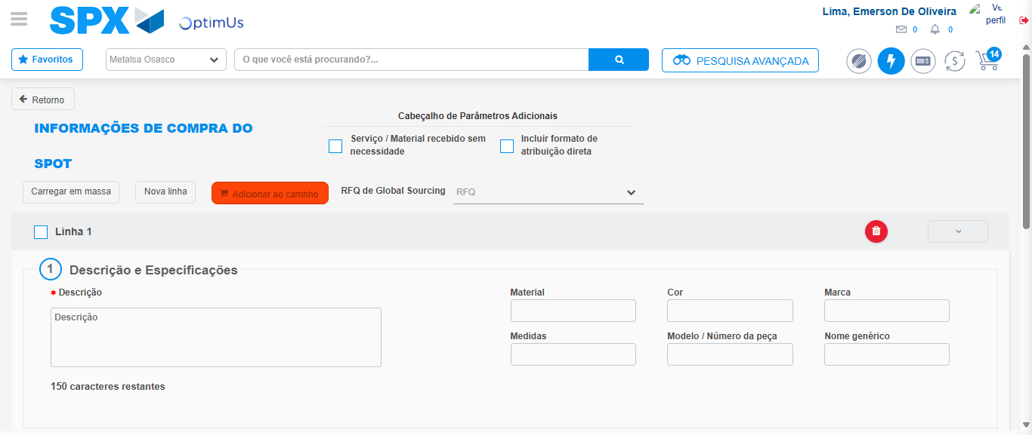Image file-name: QC_Testing-tc002_SPX_Dev5_Crear_Requisicion_Spot_Tipo_Cobro_Project-1784658056175

Image file-name: QC_Testing-tc002_SPX_Dev5_Crear_Requisicion_Spot_Tipo_Cobro_Project-1784658056374

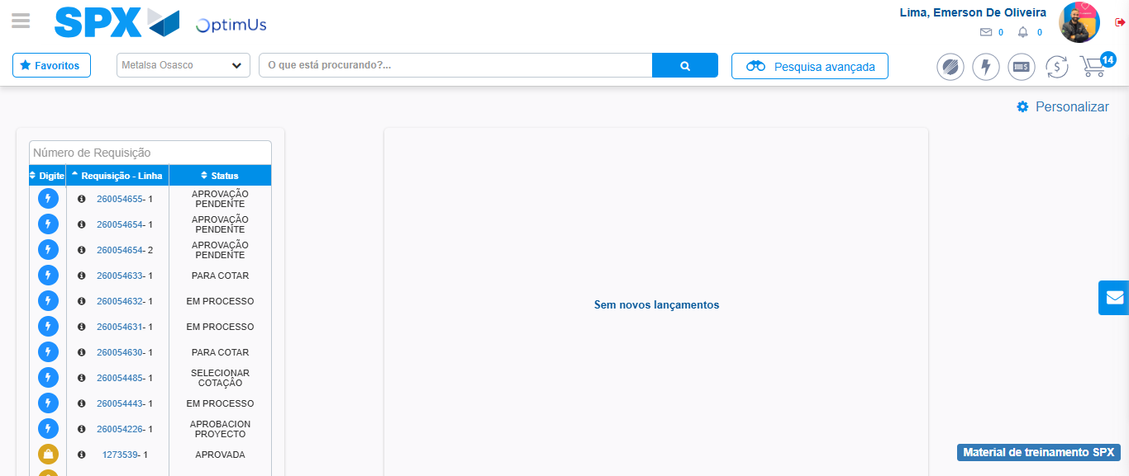Image file-name: QC_Testing-tc002_SPX_Dev5_Crear_Requisicion_Spot_Tipo_Cobro_Project-1784658077688

Step 8 - Log Out : Log Out SPX
Image file-name: QC_Testing-tc002_SPX_Dev5_Crear_Requisicion_Spot_Tipo_Cobro_Project-1784658077891

